13 September 2019:

LECTURE 2:

$$\frac{dy}{dx}=cosy+y^{2}-3y$$

$$\frac{dy}{dx}=0, f\left(y\right)=0, y=0$$

$$\frac{dy}{sx}=y\left(ay-b\right), a>b>0$$

$$\frac{y}{ay}-b=0$$

$$y=0, y=\frac{b}{a}$$

$$R_{1}:y>\frac{b}{a},\frac{dy}{dx}=y\left(ay-b_{1}\right)>0, function increases$$

$$R_{2}: 0<y<\frac{b}{a},\frac{dy}{dx}=y\left(ay-b\right)<0, function deceases$$

$$R_{3}:y<0,\frac{dy}{dx}=y\left(ay-b\right)>0, function increases$$

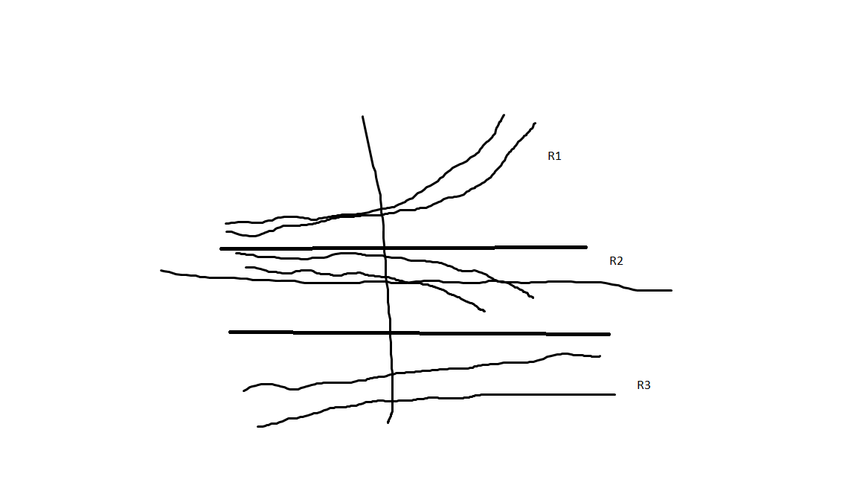

Stability of

$$\frac{dy}{dx}=f\left(y\right)→f\left(c\right)=0, y=c$$

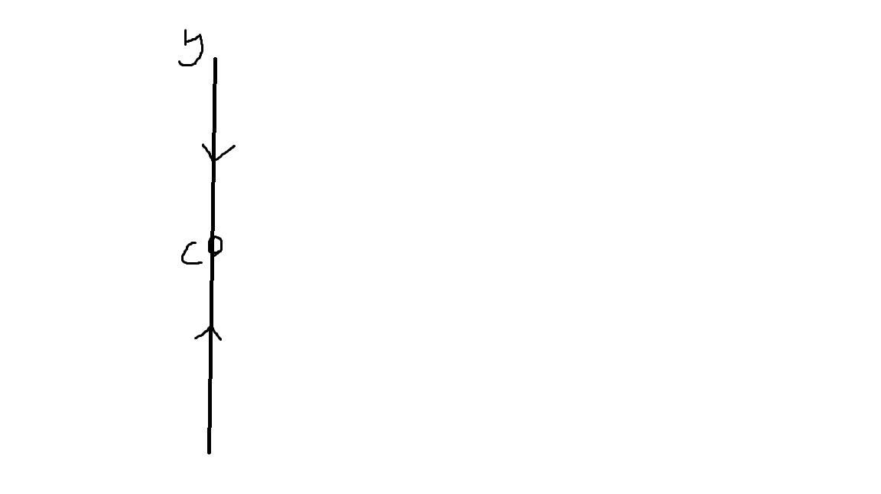

This is a asym. Stabke crit point

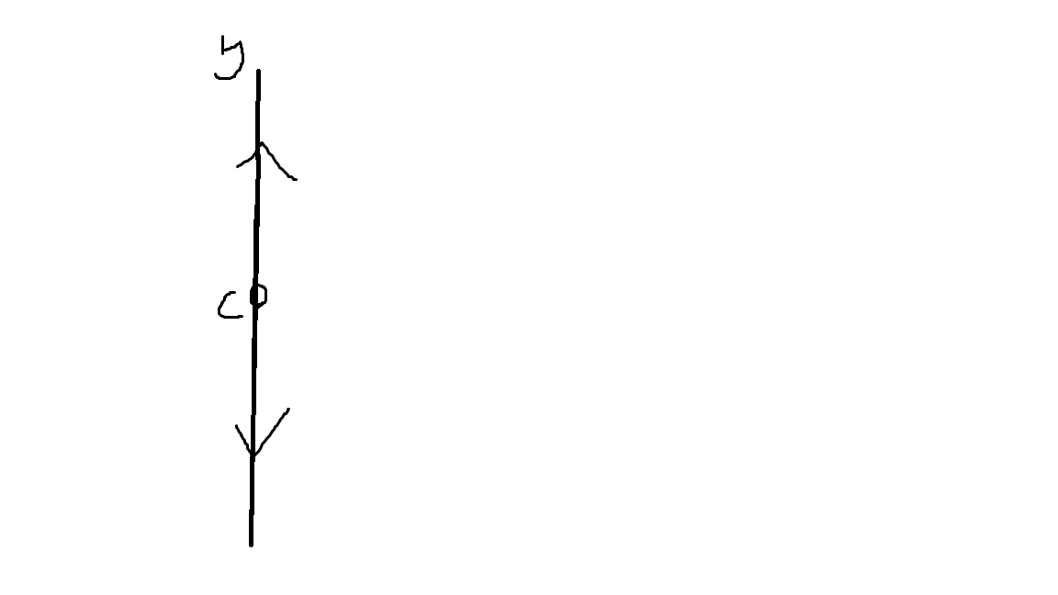

This is a asymptoticly unstable critical point

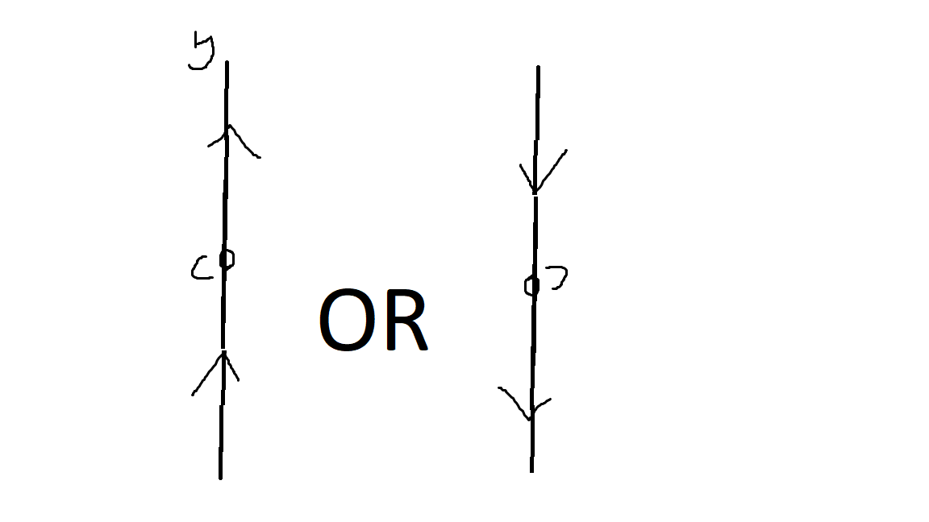

This is a semi stable critical point

IN ALL ABOVE EXAMPLE CRIT POINT c = 0

Example: Determine stability of equilibrium solutions

$$a)\frac{dy}{dx}=y^{4}-y^{2}$$

$$y^{4}-y^{2}=y^{2}\left(y^{2}-1\right)=y^{2}\left(y-1\right)\left(y+1\right)=0$$

$$Equilibrium points:c_{1}=-1, c_{2}=0, c_{3}=1$$

$$y<-1→ y^{4}-y^{2}>0$$

$$-1<y<0→y^{4}-y^{2}<0$$

$$0<y<1→y^{4}-y^{2}<0$$

$$y>1→y^{4}-y^{2}>0$$

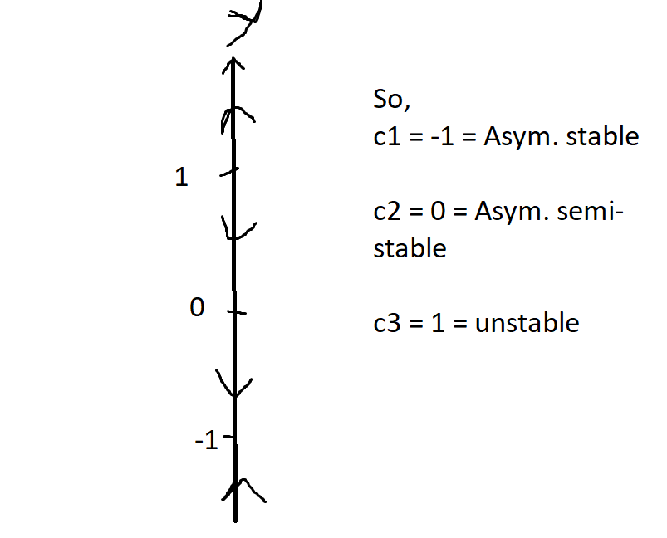

LECTURE 3:

$$\frac{dy}{dx}=e^{x+1}y^{2}→dy=e^{x+1}y^{2}dx=0$$

$$y^{-2}dy-e^{x+1}dx=0$$

$$\int{y^{-2}dy-\int{e^{x+1}dx}=C}, C=constant$$

$$-\frac{1}{y}-e^{x+1}=C$$

$$When y=0, Replace y by 0 in intial equation e^{x+1}y^{2}. We obtain 0=0, so y=0 is a singular solution$$

Example:

$$\left(1+e^{x}\right)y y^{'}=e^{x}, y\left(0\right)=4$$

$$\left(1+e^{x}\right)y\frac{dy}{dx}-e^{x}=0$$

$$\left(1+e^{x}\right)y dy-e^{x}dx=0$$

$$y dy-\frac{e^{x}}{1+e^{x}}=0$$

$$\int{y dy}-\int{\frac{e^{x}}{1+e^{x}}dx}=C$$

$$\frac{1}{2}y^{2}-\ln\left(1+e^{x}\right)=C$$

$$Substute x=0, \frac{1}{2}4^{2}-\ln\left(1+e^{0}\right)=C→C=8-\ln\left(2\right)$$

$$\frac{1}{2}y^{2}-\ln\left(1+e^{x}\right)=8-\ln\left(2\right), solve for y$$

$$y^{2}=2\ln\left(1+e^{x}\right)+16*2\ln\left(2\right) (Note:this might be miss coppied from the board)$$

$$y_{1}=\sqrt{2\ln\left(1+e^{x}\right)+16-2ln⁡(2)}$$

$$y_{2}=-\sqrt{2\ln\left(1+e^{x}\right)+16-2ln⁡(2)}$$

$$y_{1}\left(0\right)=4$$

$$y_{2}\left(0\right)=-4$$

$$…. didn^{'}t have time to copy :($$

Example:

$$y^{'}=f\left(ax+by\right)$$

$$Introduce new variable z whick is dependent on x, →z\left(x\right)=ax+by$$

$$\frac{dz}{dx}=a+b\frac{dy}{dx}$$

$$\frac{dy}{dx}=\frac{1}{b}\frac{dz}{dx}-\frac{a}{b}$$

$$\frac{dy}{dx}=\frac{1}{b}\frac{dz}{dx}-\frac{a}{b}=f(z)$$

$$\frac{dz}{dx}=a-b f\left(z\right)=0$$

$$dz=\left(a+b f\left(z\right)\right)dx=0$$

$$\frac{dz}{a+b f\left(z\right)}=dx=0$$

$$\int{\frac{dz}{a+b f\left(z\right)}}=\int{dx}=0$$

Example:

$$y^{'}=\cos\left(y-x\right), y\left(0\right)=π$$

$$z=y-x$$

$$\frac{dz}{dx}=\frac{dy}{dx}-\frac{dx}{dx}$$

$$\frac{dy}{dx}=\frac{dz}{dx}+1$$

$$\frac{dz}{dx}+1=cos⁡(z)$$

$$\frac{dz}{dx}+1-\cos\left(z\right)=0$$

$$dz+\left(1-\cos\left(z\right)\right)dx=0$$

$$\frac{dz}{1-\cos\left(z\right)}+dx=0$$

$$\int{\frac{dz}{1-\cos\left(z\right)}+\int{dx}=C}$$

$$\int{\frac{dz}{1-\cos\left(z\right)}}=\int{\frac{dz}{2\sin^{2}{\frac{z}{2}}}}, u=\frac{z}{2}, du=…$$

$$\int{\frac{du}{\sin^{2}{u}}={-cot}^{2}{\frac{z}{2}}+c}$$

$$-\cot^{2}{\frac{z}{2}}+x=C$$

$$\cot\left(\frac{z}{2}\right)=x-C$$

$$\frac{z}{2}=\operatorname{arccot}\left(x-C\right)$$

$$z=2 \operatorname{arccot}\left(x-C\right)$$

$$y=z+x=2 \operatorname{arccot}\left(x-C\right)+x$$

$$y\left(0\right)=2 \operatorname{arccot}\left(0-C\right)=π$$

$$\operatorname{arccot}\left(C\right)=\frac{π}{2}→C=0$$

$$Donc solution, y\left(x\right)=2 \operatorname{arccot}\left(x\right)+x$$

Is it a unique solution?

$$1-\cos\left(z\right)=0$$

$$\cos\left(z\right)=1 (when will\cos\left(z\right)=1?When z=0, -π, 2π, etc)$$

$$z=2πn , n=0, ±1, ±2, …$$

$$y=z+x=x+2πn$$

$$y^{'}=\cos\left(y-x\right)$$

$$y^{'}=1,\cos\left(y-x\right)=\cos\left(2πn\right)=1$$

$$y=x+2πn, n=0, ±1, ±2 are solutions of DE$$

$$IVP. y\left(0\right)=2πn ≠π$$

Exercise:

Solve DF,

$x^{2}y^{2} y^{'}+1=y$

${\left(2y+3\right)}^{2}dx-{\left(4x+5\right)}^{2}dy=0$

**Homogenous or not:**

$$y^{'}+e^{x}y=0, →homogenous$$

$$2y^{2}-\cos\left(y\right)+7x=0, not homogenous because 7x$$

$$\left(1+e^{x}\right)y^{'}+\cos\left(x\right)y=x^{3} (general form)$$

$$y^{'}+\frac{\cos\left(x\right)}{1+e^{x}}y=\frac{x^{3}}{1+e^{3}}$$

Example:

$$\frac{dy}{dx}+f\left(x\right), y=f\left(x\right)$$

$$y\left(x\right)=y_{c}\left(x\right)+y_{p}(x)$$

$$y_{c}^{'}\left(x\right)+f\left(x\right) y_{c}\left(x\right)=0$$

$$\frac{y_{c}^{'}\left(x\right)}{y_{c}\left(x\right)}=-f\left(x\right)$$

$$\frac{d\left({}\right)}{dx}=-f\left(x\right)$$

$$\int{\frac{d\left(\ln\left|y_{c}\left(x\right)\right|\right)}{dx}dy}=-\int{f\left(x\right)dx}$$

$$\ln\left|y_{c}\left(x\right)\right|=\int{f\left(x\right)dx}+c$$

$$y_{c}\left(x\right)=c e^{-\int{f\left(x\right)dx}}$$

Example

$$y^{'}+p\left(x\right)y=0$$

$$y_{c}\left(x\right)=c e$$

$$y_{p}^{'}+p\left(x\right)y_{p}=f(x)$$

$$y_{p}\left(x\right)=C\left(x\right) e^{\int{p\left(x\right)dx}}$$

$$C\left(x\right) is unknown$$

$$y_{p}^{'}\left(x\right)=C^{'}\left(x\right) e^{-\int{p\left(x\right)dx}}+C\left(x\right)\frac{d\left(e^{-\int{p\left(x\right)dx}}\right)}{dx}$$

$$-C^{'}\left(x\right) e^{-\int{p\left(x\right)dx}}+C\left(x\right) e^{-\int{p\left(x\right)dx}} \frac{d\left(-\int{p\left(x\right)dx}\right)}{dx}$$

$$y_{p}^{'}\left(x\right)=C^{'}\left(x\right)e^{-\int{p\left(x\right)dx}}-\cos\left(p\left(x\right)\right)e^{-\int{p\left(x\right)dx}}$$

Substitute in $y_{p}^{'}+p\left(x\right)y_{p}=f(x)$

Donc,

$$C^{'}\left(x\right) e^{-\int{p\left(x\right)dx}}-\cos\left(p\left(x\right)\right)e^{-\int{p\left(x\right)dx}}+p\left(x\right)cos⁡()$$

$$C^{'}\left(x\right)=e^{-\int{p\left(x\right)dx}} f(x)$$

$$C\left(x\right)=\int{e^{-\int{p\left(x\right)dx}} f\left(x\right)dx}$$

$$y_{p}\left(x\right)=e^{-\int{p\left(x\right)dx}}*\int{e^{-\int{p\left(x\right)dx}} f\left(x\right)dx}$$

Solve:

$$y^{'}+p\left(x\right)y=f\left(x\right)$$

$$1. IF:e^{\int{p\left(x\right)dx}}$$

$$2. e^{\int{p\left(x\right)dx}}y^{'}+p\left(x\right)e^{\int{p\left(x\right)dx}} y=e^{\int{p\left(x\right)dx}} f(x)$$

$$3.\frac{d\left(e^{\int{p\left(x\right)dx}} y\right)}{dx}=e^{\int{p\left(x\right)dx}} f(x)$$

$$e^{\int{p\left(x\right)dx}} y= \int{e^{\int{p\left(x\right)dx}}} f\left(x\right)dx+C$$

$$y=e^{-\int{p\left(x\right)dx}}\left(\int{e^{\int{p\left(x\right)dx}}} f\left(x\right)dx+C\right)$$

Example:

$$\frac{dy}{dx}+2xy=2x^{3}$$

$$1. IF p\left(x\right)=2x, e^{\int{p\left(x\right)dx}}=e^{\int{2xdx}}=e^{x^{2}}$$

$$2. e^{x^{2}} \frac{dy}{dx}+2x e^{x} y=2x^{2}e^{x^{2}}$$

$$3. \frac{d\left(e^{x^{2}}y\right)}{dx}=2x^{2}e^{x^{2}}$$

$$4. \int{\frac{d\left(e^{x^{2}}y\right)}{dx}dx}=\int{2x^{2}e^{x^{2}}}$$

$$e^{x^{2}}y=\int{x^{2}d\left(e^{x^{2}}\right)=x^{2}e^{x^{2}}-\int{e^{x^{2}} d\left(x^{2}\right)}}$$

$$x^{2}e^{x^{2}}-\int{2x}e^{x^{2}}dx=x^{2}????$$

$$y\left(x\right)=e^{x^{2}}\left(x^{2}e^{x}+c\right)$$

$$=c e^{-x^{2}}+x^{2}-1$$

$$Here, c e^{-x^{2}}is y_{C} and x^{2}-1is y_{p}$$

Exercice:

$$\sin\left(x\right)\frac{dy}{dx}+\cos\left(x\right)y=x\sin\left(x\right), y\left(\frac{π}{2}\right)=z$$

Example:

$$y^{'}+y=f\left(x\right), x∈\left(0, ∞\right), f\left(x\right)=$$

$$y\left(x\right)=2$$